Coding the game Eenie Meenie Miney Moe

Implement the game *Eenie Meenie Miney Moe* in Python. Your program should:

* Input a list of players and the phrase that will be used to eliminate players
* Use a nested loop to play the game until only 1 player remains
* In each round, print:
  + The remaining list of players
  + Who gets pointed at with each word
  + 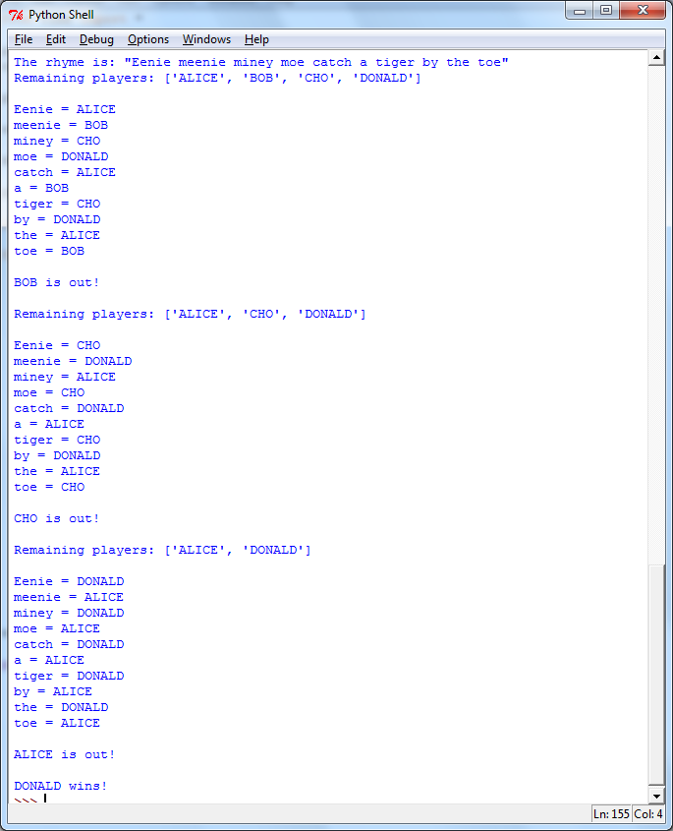Who is out

**Example output**: